Introduction

Preliminary investigation of the existing quality of library provision within the city identified 5 key areas from which it was felt significant improvement could be effected:

- Architectural Design
- Spatial Qualities
- Technology
- Function
- Location

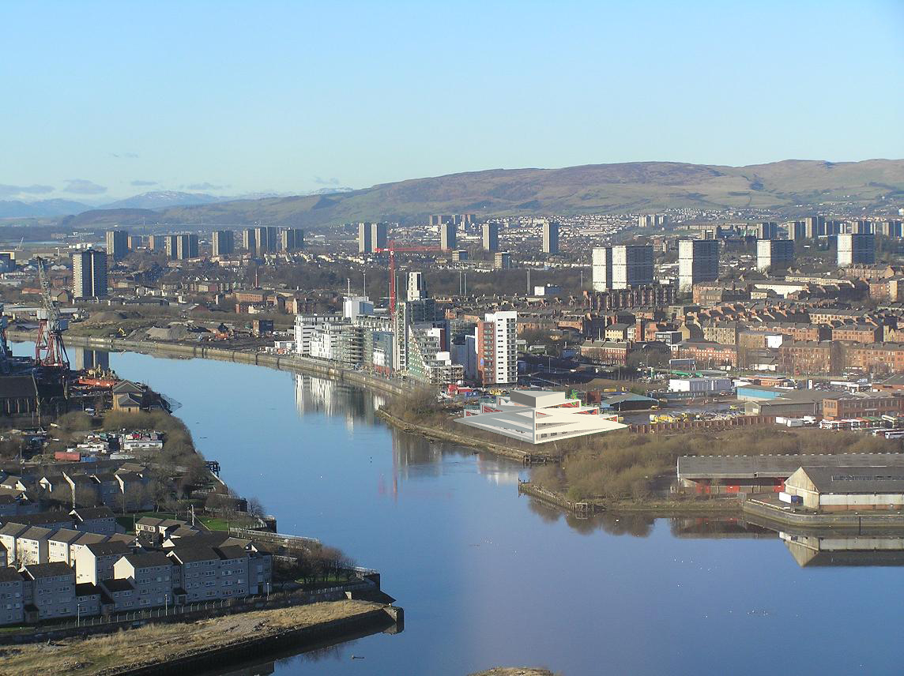

- Architectural Design

Outline proposals detailed a range of massing options from which a pyramidal form was settled upon after discussion with client. It was thought this represented the most visually arresting solution satisfying the brief for a landmark build. Detailed investigation revealed a continuous sloping roof to be inefficient at maximizing commercial floorplates, examination of historical precedent from the ancient world led to a stepped arrangement which permitted the establishment of balcony spaces. These spaces take advantage of an open aspect, blurring the distinction between the indoor and outdoor world.

With underlying form settled upon it was felt a more honest interpretation of source inspiration would achieve greater academic reward. Insight gained to the psychology and drivers of the ancient mind was found to provide innovative and effective solutions surprisingly applicable to a contemporary setting.

A feature sculpted prow to the Clyde was achieved by employing quarter symmetry to a pyramidal form, this references ship building heritage through evocation of the Queen Mary. Though conscious of the clichéd narrative of this form it was felt too visually evocative to ignore. The uppermost level was refined to a glazed conservatory space in order to maximize views from the building by day and views to the building by night. A retractable wall can be closed in inclement weather, copper tinted glazing being a powerful solution to the admittance and refraction of light whilst maintaining metallic demeanour.

It is intended for the architecture to stimulate debate and excite interest amongst the general public such that it may be hoped to attract those whom would not ordinarily pass the doors of a library, intrinsic qualities are such that these new users would be stimulated to make repeat visits.

2. Spatial Qualities

Exaggerated exterior walls of reinforced concrete support external travellators granting direct access to individual floors and egress to the upper level observatory whilst providing stability for expansive open plan floorplates. An elevator shaft is sunk into the prow of the structure to enable disabled access. A central open plan hall engenders an atmosphere of space and freedom assisting easy navigation in a conscious deviation from the claustrophobic corridors and inefficient spaces of Edwardian libraries. Extensive glazing allows penetration of natural daylight thus reducing dependence on artificial light, improving the reading experience. Unique angled windows present a dynamic interplay of refracted light painting a changing scene with the passage of time.

To accentuate perception of scale and elicit a sensation of awe from new arrivals shortcuts in performance of the eye were taken advantage of. Configured to perceive common objects as equivalent in scale to save on brain processing, a repeated triangular motif of door and window openings was devised to subtly decrease in size over successive tiers such that the upper level pavilion appears grander than reality. Alignment of balcony doors converge at a single point of reference pointing the way to the heart of the building for new arrivals approaching via a ceremonial avenue. 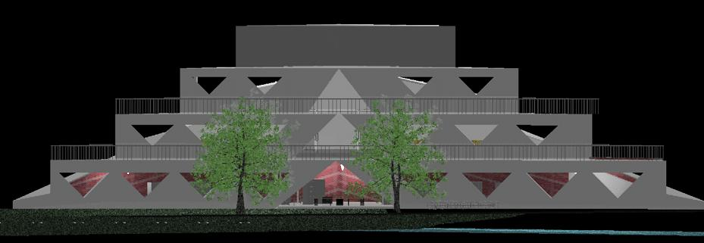

- Technology

Wishing to avoid the predictability of architecture as inanimate object I have drawn on techniques pioneered by Rogers Lloyds of London to introduce movement and dynamism to the scene by way of external elevators, gantry cranes. Such features create a genuine machine aesthetic distinct from the intellectual hyperbole of high modernism.

Birds eye perspective of roofscape has been demoted to afterthought with the demise of the gods but with increasing proliferation of high rise development elevating the status of mortals it is becoming an increasingly important design consideration. Here a delta wing profile evokes the engineering prowess of the U.S military, aircraft physics being relevant to consideration of wind dynamics.
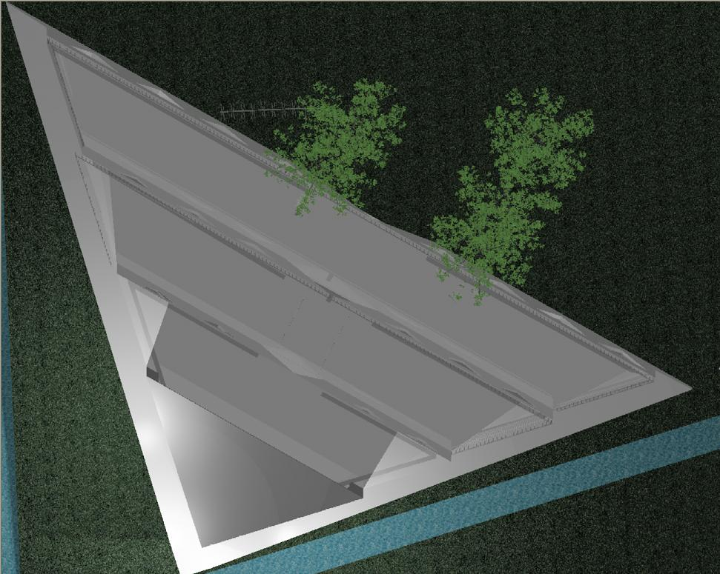

A contemporary materials palette is required to accentuate the new future being wrought for the area without cloying sentimentality for the past. A selection of metals and stone were investigated for their solidity, presence and quality referencing the shipbuilding heritage of the area without resorting to lazy pastiche. This led to the selection of Titanium as a robust response to an exposed site providing visual coherence with the Science Centre complex upriver.

- Function

A constricted site bounded by natural barriers informed the decision to build upward rather than outward with a tiered structure demonstrating clarity of purpose through segregation of usage by floor level, easing navigation and simplifying design. Soundproofing is provided by extra thick walls insulating the interior from disturbance.

The library interior is finished in a warm brick to facilitate a homely atmosphere conducive to sensations of comfort and safety thus enabling the pursuit of learning in a relaxed environment.
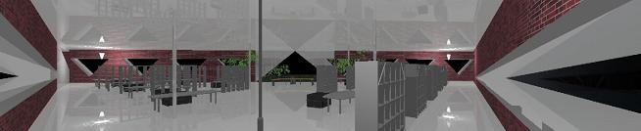

- Location

Enjoying open east, west aspect across the Clyde and south to Govan. This favoured geography presents both opportunity and challenge.

The site employs a series of perimeters enclosing rings of parking, landscaping and reception activity outwith the inner core of book repository. A contiguous walkway along the riverfront is established through granite setts, a proposed pedestrian bridge over the Kelvin, CCTV and lighting standards serve to minimise the crime threat and illuminate building and grounds for added night drama. A tree lined avenue denotes primary public entrance and beds the architecture into the surrounding landscape.

Toxic concrete manufacturing processes and transportation will be offset through thermal efficiencies through thick set insulated walls when considered across projected lifespan. A modest increase in traffic may be felt on existing infrastructure but the site is well served by bus and rail routes whose usage will be favoured through advertisement, cycle stands and limited parking availability.

Conclusion

Though culturally alien and geographically distant we share common ancestry and biology with ancient civilisations. With expansion in travel and communication it is a natural progression to seek inspiration from further afield whilst still delivering distinctive Glaswegian flavour. A fitting expansion of the European tours undertaken in the 18th & 19th centuries.



